**PARADE USER GUIDE**

**Language translation**



**Version 1.50 Apr 2021**

**Version History**

|  |  |  |  |
| --- | --- | --- | --- |
| **Version** | **Date** | **Author** | **Comments** |
| 1.41 | Oct 2020 | K.Wilson | Original Version |
| 1.50 | Apr 2021 | K.Wilson | Update to reflect change in captions and when forms are translated |

Contents

Overview 1

Setting up a language 1

Entering translations 3

Translating forms 4

# Overview

Although PARADE is developed in English, it is possible for menus, buttons, text etc to be displayed in another language, including those that use glyphs, such as Chinese and Japanese, other alphabets, such as Korean, Russian or Thai or those that use additional diacritics on the standard Latin alphabet, such as many European countries.

In order to maintain a single source code and program for all languages, the translations are handled via a series of tables where translations for the standard text are defined. This also means that when the program is updated, users are able to enter the translations for any addition text or options themselves.

These are defined in several tables including Menu items, buttons, long and short text.

# Setting up a language

Many users will not need a translation at all. Translations options will only occur when the file language.pxd exist in the Parade system directory, usually c:\parade.

If it exists, this file defines the alternative language and turns translation on or off.

The language is defined in the Translate menu

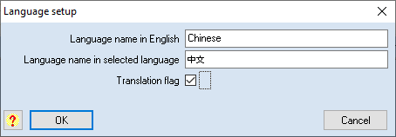

The alternative language is entered in English and in the language itself and the translate flag is used to turn translation on or off, and reflects the value of the translation check box on the main form.

It is hoped that once translations are available for a particular language, they can be made available on the Parade website for other users.

If the file exists, the Translate menu will be visible and the main form will have a checkbox to turn the alternate language on or off.

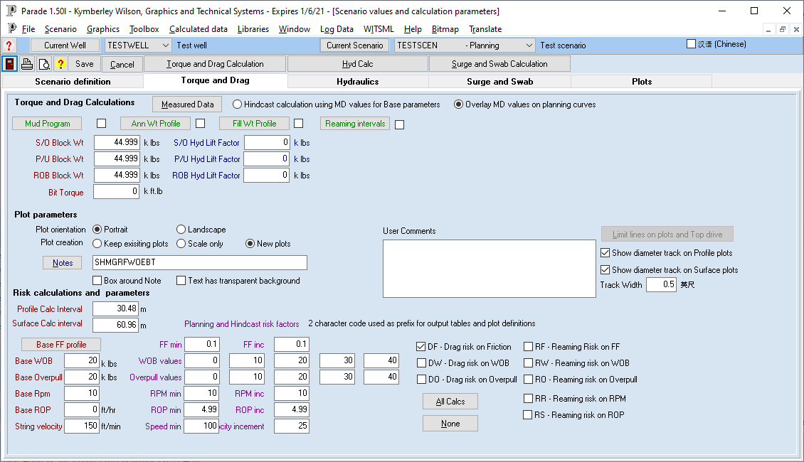

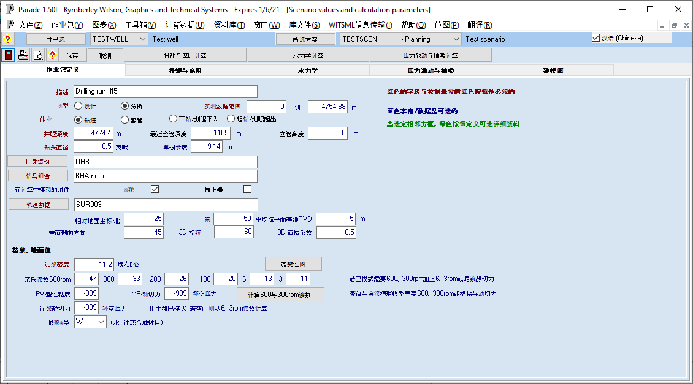

# Entering translations

There are several translation tables used and they are all accessible on the Translate menu.

When a new language is set up, Parade will automatically create these tables with the original text, plus in some cases, some identifier for internal use, eg the name of the menu.

The translation into the other language is then entered. Note that there are a large number of entries that need to be made, so it would be good practice for users in the same company to designate one person to do the translation and then share the files with other company members.

Eg for the Menu Names

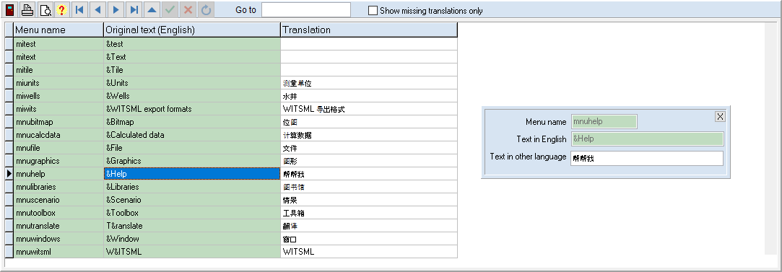

Each record in the table can have its translation entered. The records to be translated are added by the program and therefore do not need to be added or deleted by the user.

If the translation value is empty the original text will be displayed in both languages.

Not that for some text an & appears. This causes the following letter to be underlined and that letter can be used with the ALT key as a shortcut. For Alphabetical languages, an & can be used for a short cut in the alternate language. However, care should be taken not to use the same letter for more than one item in any menu.

The check box can limit the records displayed to only those without a translation, making it easy to see where new values have been entered since an earlier version.

The 4 translation tables are:

Menu names – This just contains the names of the menu items. It has the menu item as a key field and so can translate to the alternative language and then back to English.

Captions – This table holds captions for text labels, checkboxes or radio buttons which are longer than 50 characters and up to 250 characters in English. It contains the original text and the translation so text that appears on several forms needs to be translated only once.

Text – this holds the text for all other components on the forms, of length up to 50 characters in English. Since the same text may used in multiple places (eg “Process” on a button) only the original and translated text is displayed.

Source code - This holds all the text that is created in code. This will be displayed in the selected language and this can be turned on or off. Only the English values and the translated values are in this table, since the text may be used in multiple places.

# Translating forms

The main form, menus and edit forms will be translated immediately when the language check box is checked or unchecked.

However, Dialogs are modal and hence the language checkbox is not accessible until the dialog is closed. It will be translated when it is opened again.

Plot forms must also be closed and reopened before the translation occurs. In addition, the plots themselves must be recreated in order to be displayed in the other language.